### Tackling Plastic Bottle Pollution:

### A Comprehensive Plan

**Abstract**

Plastic is a ground-breaking material. It is one of the most common human-made products on the planet due to its unique characteristics of being highly mouldable, durable, lightweight, and inexpensive to produce. It saves money on transportation, keeps food fresh, and serves important medical purposes. Since the 2010s, plastic consumption has grown dramatically, and plastic production is expected to double in the next two decades. Plastic waste generation has quadrupled in India over the past ten years. Also, the pandemic created a surge in plastic production. To help tackle plastic waste generation in India, we have created a framework to study Plastic Generation, Plastic Wastage, and the Recycling Rate of Plastic.

**Literature Review**

We have implemented an existing idea that is currently an ongoing process in Australia of REVERSE VENDING Machines. Introduction of Australian base plastic bottle recycling model in the Indian system to study the trend of plastic recycling and the effect of this system on per year plastic pollution. Intensive Prediction of the Reverse Vending Machines Requirement. We have investigated the rate of plastic generation against the rate of plastic recycling rate. We have also predicted the effects of using vending machines in India and how will they help in reducing plastic pollution. Machine learning techniques show significant prediction results in tackling plastic pollution. Machine learning algorithms can be used to predict when machines used in plastic manufacturing processes are likely to fail. By detecting issues early, it can prevent unplanned downtime and reduce the number of plastics that are scrapped due to production defects. Machine learning can also be used to improve the efficiency of plastic recycling processes. For example, machine learning algorithms can be used to detect impurities in plastic waste, which can make the recycling process less efficient. By removing impurities, it would be possible to recycle more plastic waste.

**Objective**

Our aim for this project is to sustainably reduce plastic pollution and also implement the sustainable methods that are used in other countries. Here we focus to provide a prediction of the time and machine requirements at which the rate of production of plastic will decrease as a result of the increasing rate of recycling of plastic. Using our prediction model we want to create awareness that India can also defend against the upcoming excess plastic waste in the upcoming decade.

**Introduction**

Machine learning and reverse vending machines can play a significant role in reducing plastic waste by encouraging recycling and promoting a circular economy. Reverse vending machines are automated machines that accept used beverage containers such as plastic bottles, cans, and glass bottles and provide a financial or non-financial incentive in return. The reward encourages people to recycle and reduces littering, as people are more likely to dispose of their empty containers properly if they can receive a reward for doing so.

These machines have been used for many years in countries such as Germany, Australia, and Sweden, where they have proven to be an effective way of promoting recycling.

Machine learning can be used to improve the performance of reverse vending machines by identifying and sorting different types of containers accurately. The technology can also help to detect fraud and prevent misuse of the machines. For instance, machine learning algorithms can be trained to recognize the unique features of different types of plastic bottles, such as their shape, size, and brand. This will enable the reverse vending machine to sort and separate the bottles automatically, making the recycling process more efficient and effective.

Machine learning can help to optimize the design of reverse vending machines to make them more user-friendly and appealing to customers. For example, the technology can be used to analyze customer behavior and preferences, such as the time of day they are most likely to use the machines, the type of reward they prefer, and the location of the machine. Machine learning can improve the performance of reverse vending machines and promote recycling, which is an essential step toward reducing plastic waste and achieving a more sustainable future.

In this paper, we explore the challenges and best practices for predicting the levels of plastic waste that can be reduced with the help of these vending machines.

We have gathered all our data from the CPCB – Central Pollution Control Board, Government of India.

Here is the website link: <https://cpcb.nic.in/index.php>

We have considered data from 2011 to 2020. And on basis of this data, we have predicted no of machines required per state and their per-year recycling capacity.

We also have assumed plastic bottle production from the year 2021 to 2030 and on basis of these assumptions we have determined the rate at which the machines will fulfill the total plastic waste recycling capacity for India.

﻿

Reading of the Dataset that consists of 34 states of India plastic pollution data.

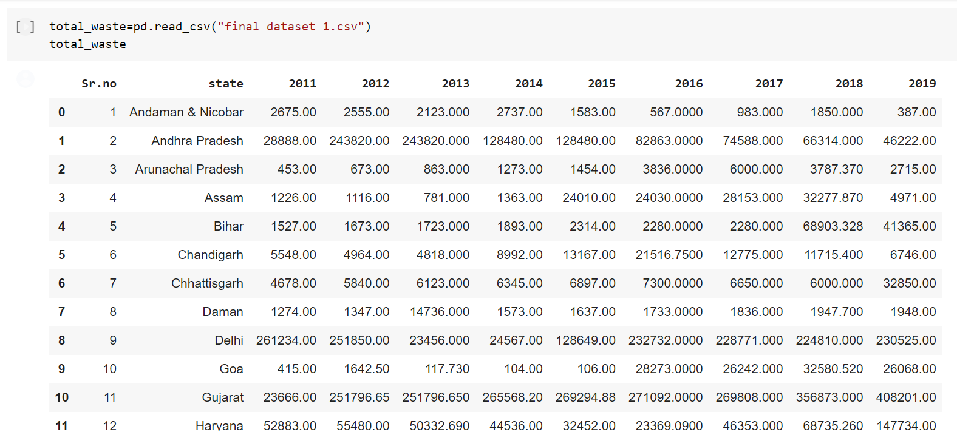

Finding out the average plastic pollution for all 34 states that will be required for the prediction of the number of reverse vending machines:

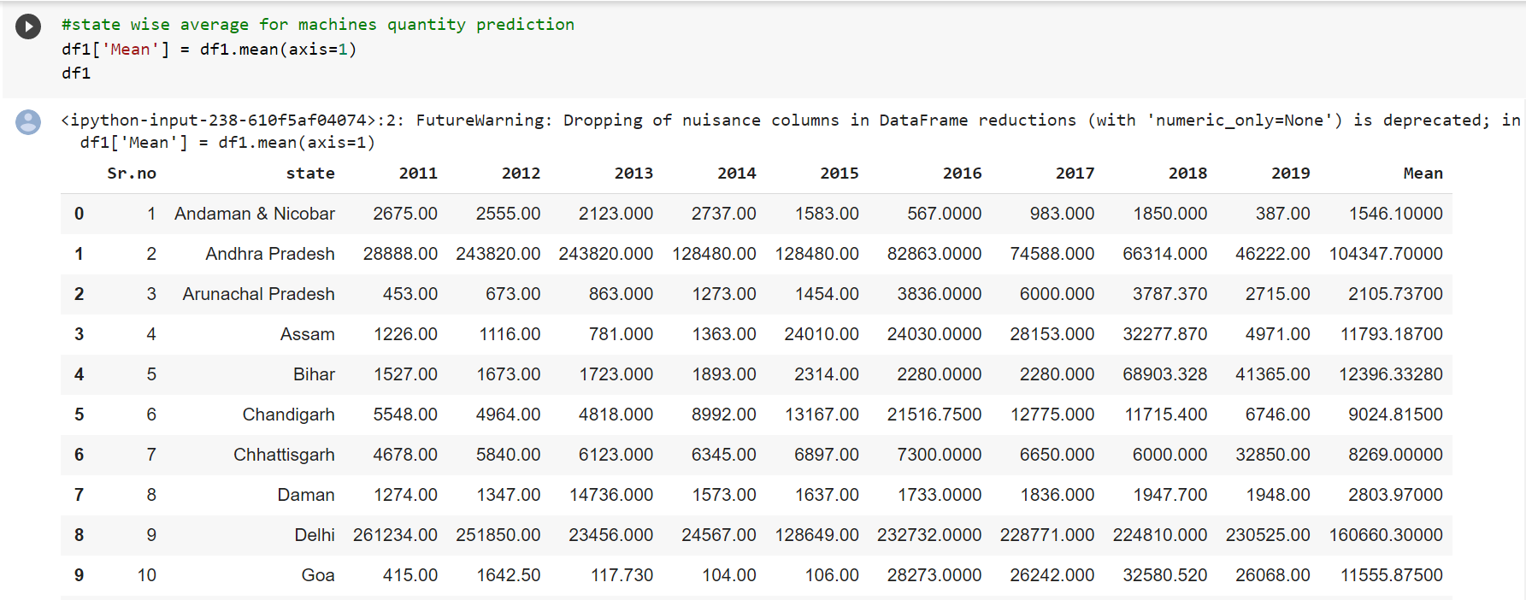

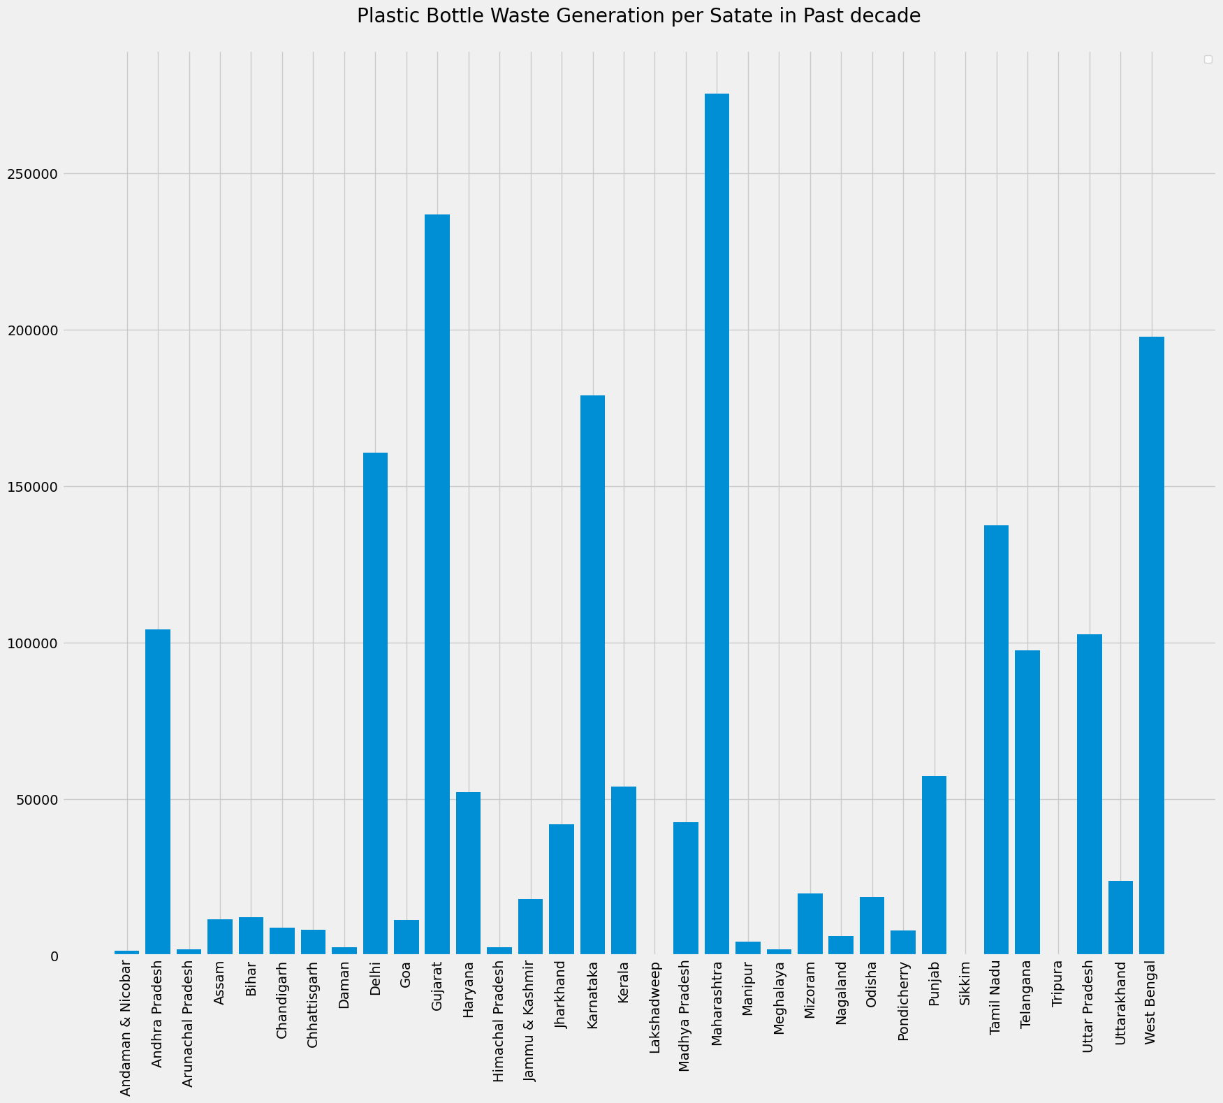

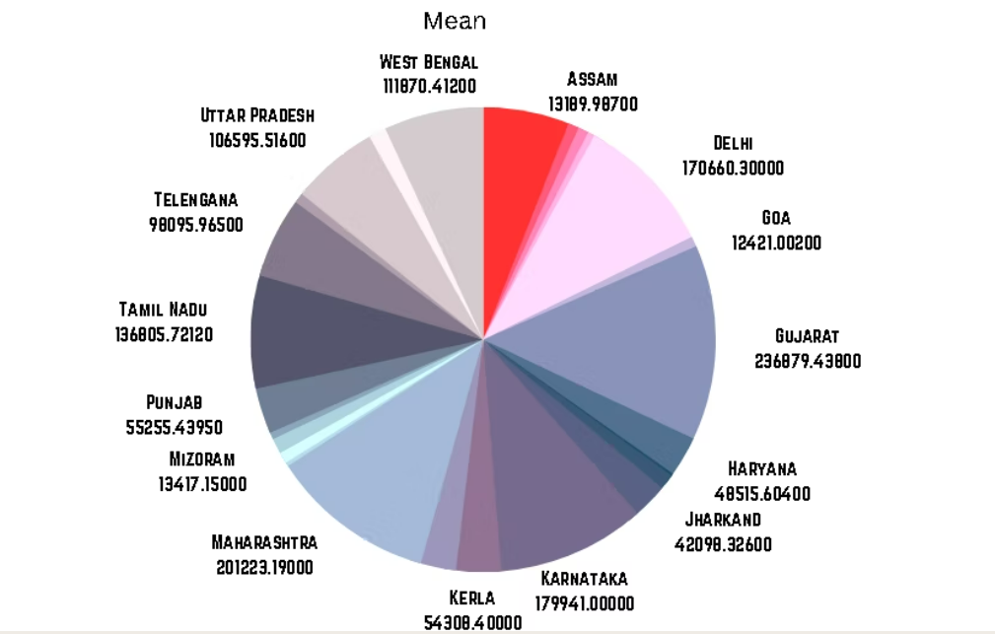

Evaluation of the increase in plastic waste in the past decade

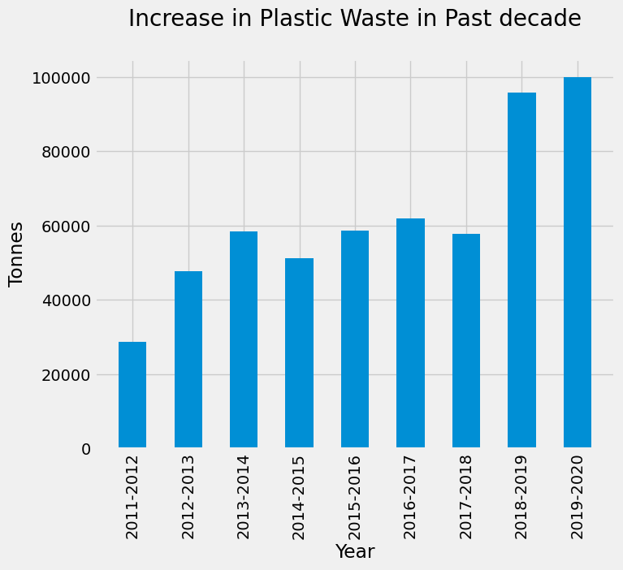

This was evaluated in order to find the Rate of increase in plastic waste that would be used to predict the number of machines required.

Prediction of the Number of Reverse Vending Machines

The average weight of a plastic bottle =10grams

The capacity of a reverse vending machine= 550 bottles

So according to this data if per day 550 bottles are collected in a machine then the total weight will be 5500 grams per day. So for a month, it’s about 165000 grams =165kgs approx. of bottle weight. According to this the yearly capacity of a single reverse vending machine will be 1.91625 tonnes of plastic bottles.

The capacity of a Single Reversing Vending Machine

Per Year = 1.91625 tonnes

Per Month = 165 Kilograms

Year day= 5.5 kilograms

Hence relating to this calculation the Number of reverse vending machines required initially is calculated.

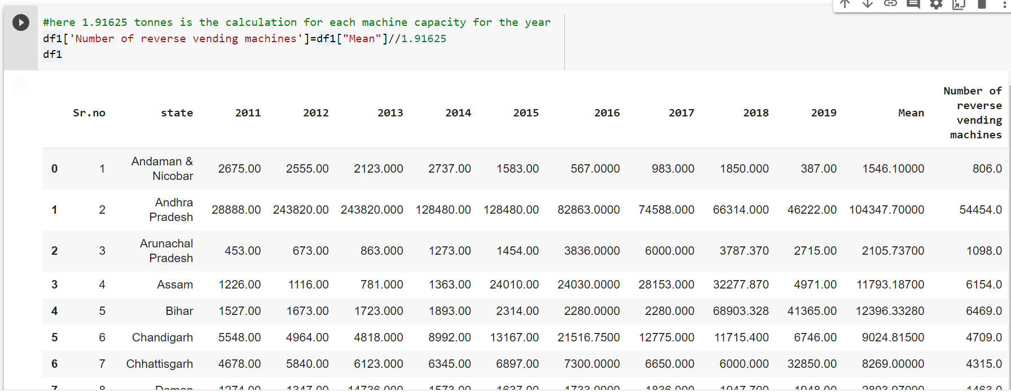

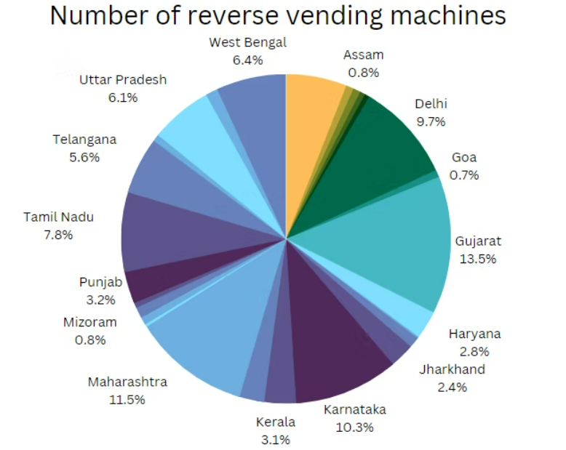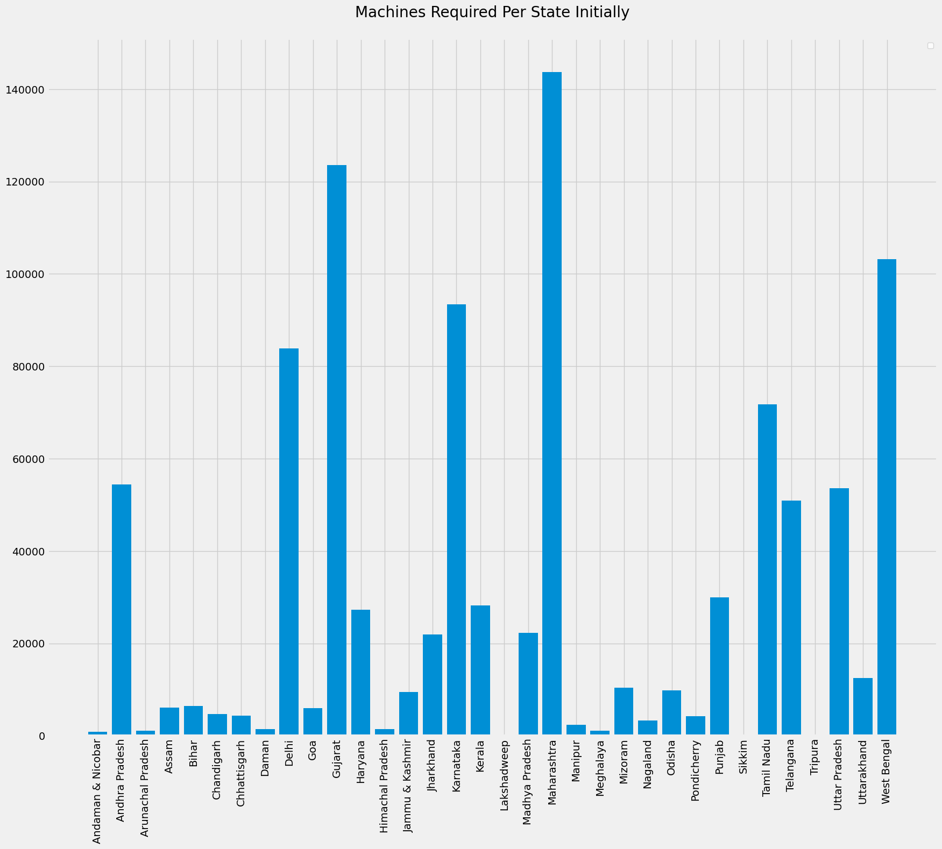

Approx. Total of 1000000 (10 Lakhs) Machines needed

Here we will focus on the prediction of further 2 decades with our machine prediction and effects on the recycling rate and production rate

Prediction for the Years 2020 to the Year 2030:

Plastic Waste Generation is Increasing by 2% to 7% For the first decade. Machine Numbers Increased by 1%-2% per Year and Machine Recycling Capacity Increased by 3%-4% per Year respectively.

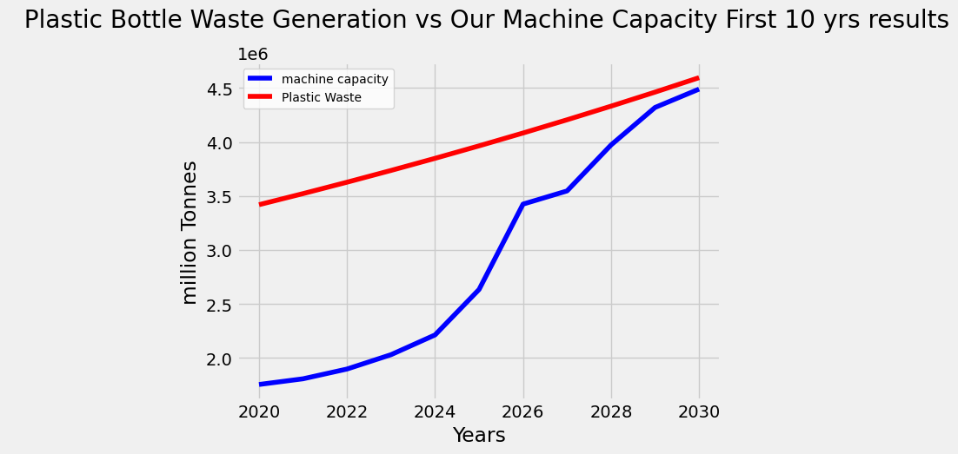

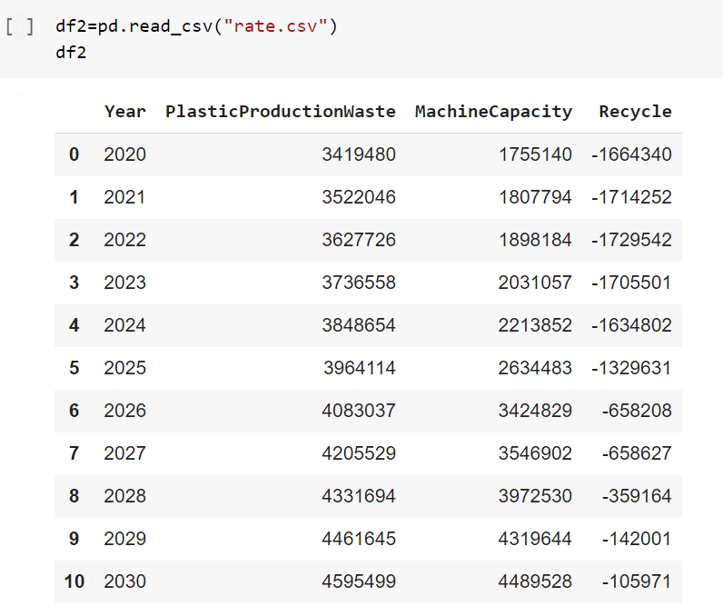

Using the prediction graph above we can find that if the rate of plastic waste increase against the increase in the number of reverse vending machines hence at some point we will able to meet the requirement for the plastic to get collected and recycled.

Here is the recycle rate prediction:

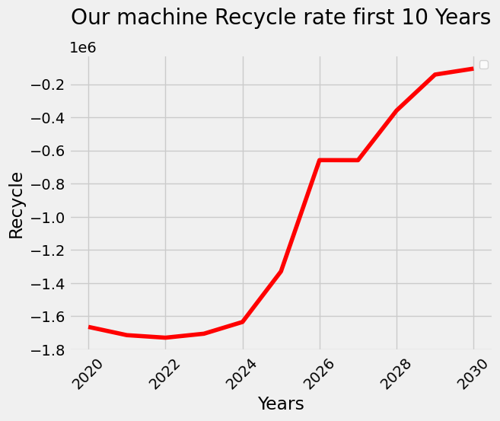

Recycling Rate is negative initially since machine capacity is less than total Plastic Bottle waste generation. The recycling Rate will increase down the decades.

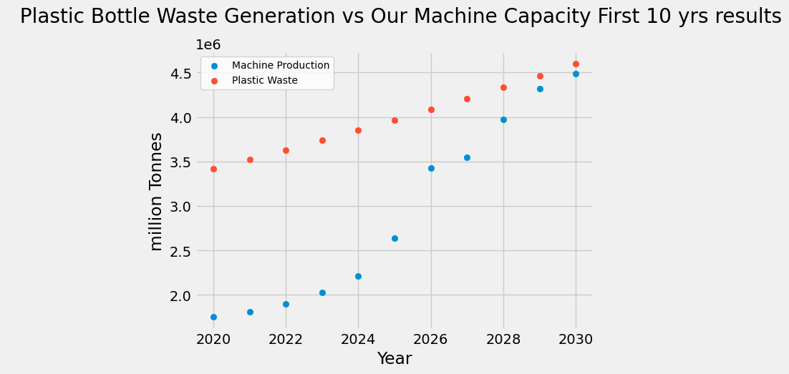

Prediction for the Year 2020 to the Year 2040:

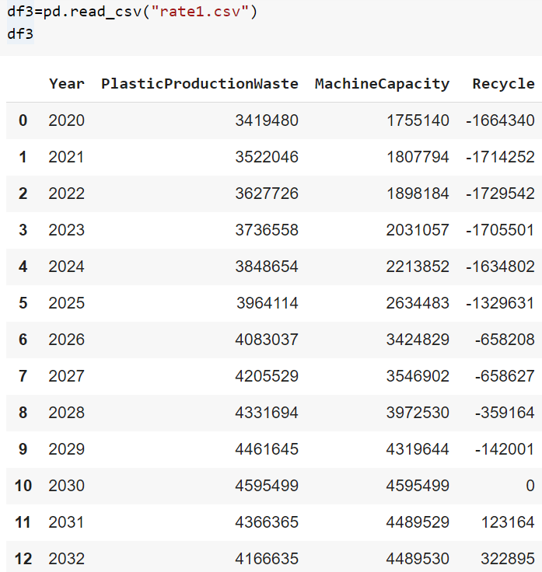

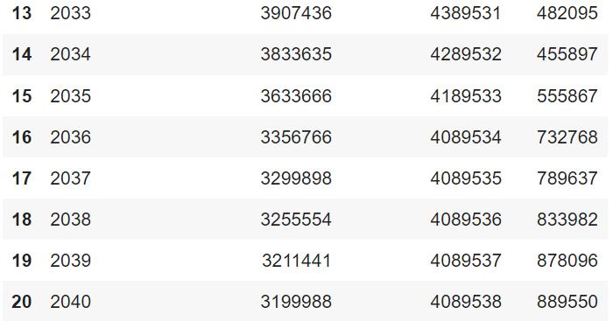

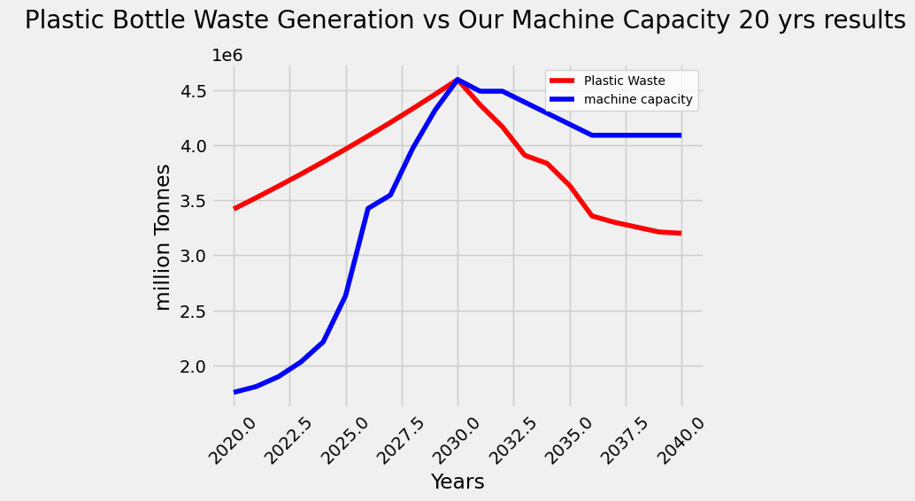

Here Machine Recycling Capacity has Surpassed Plastic Bottle Waste Generation. The point where both curve meet is the point from which the recycling rates increase and plastic waste reduces

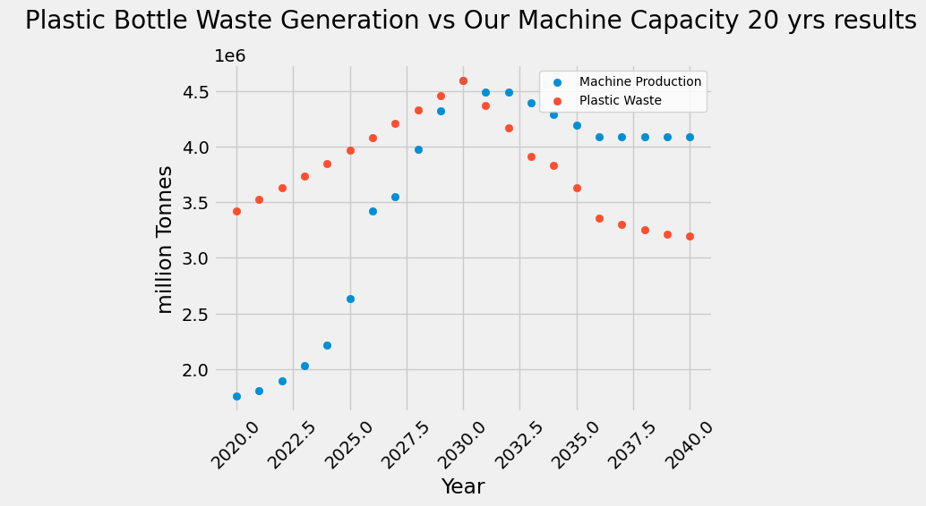

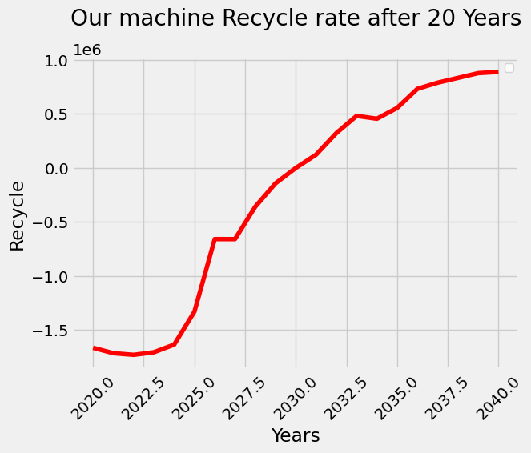

Here is the curve of the recycling rate. If we meet this recycling rate then we will be able to sustainably reduce plastic waste in India.

Here is the data set for the total plastic pollution and the impact of our

machines’ prediction of the plastic that is recycled. As the recycling rate increases the total plastic pollution also decreases gradually

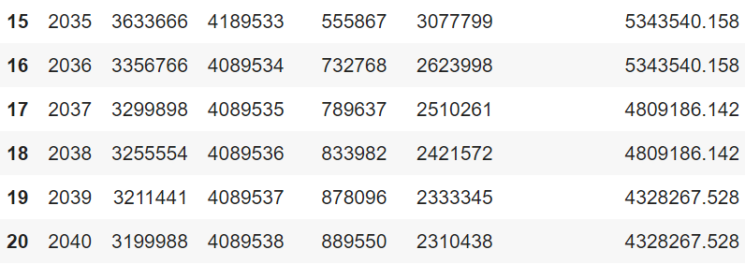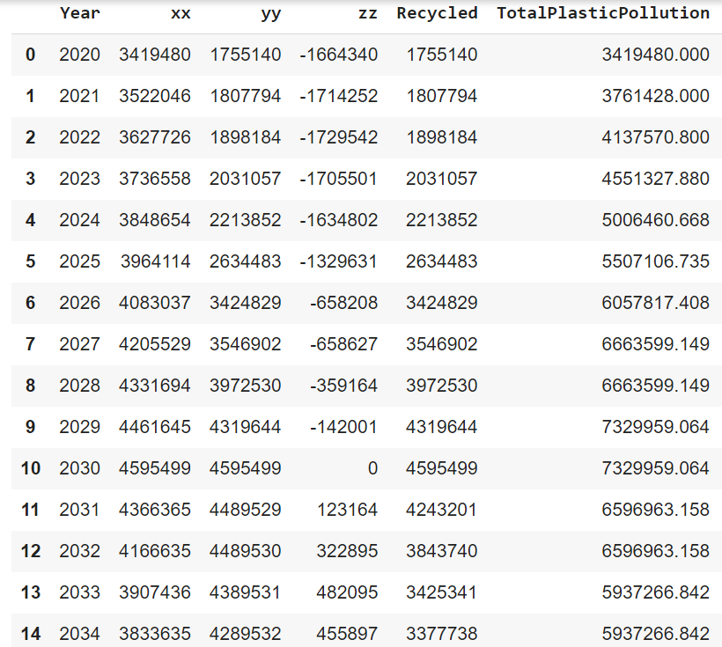

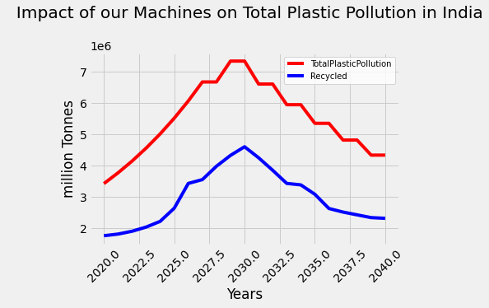As the recycling rate increases the total plastic pollution also decreases gradually

Logistic Regression model:

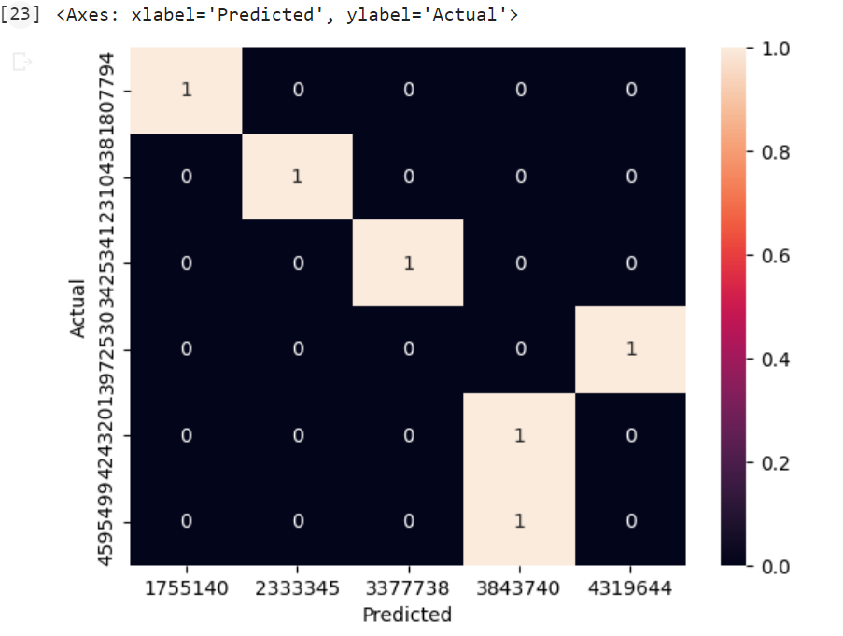

Logistic Regression was the most accurate of this prediction.

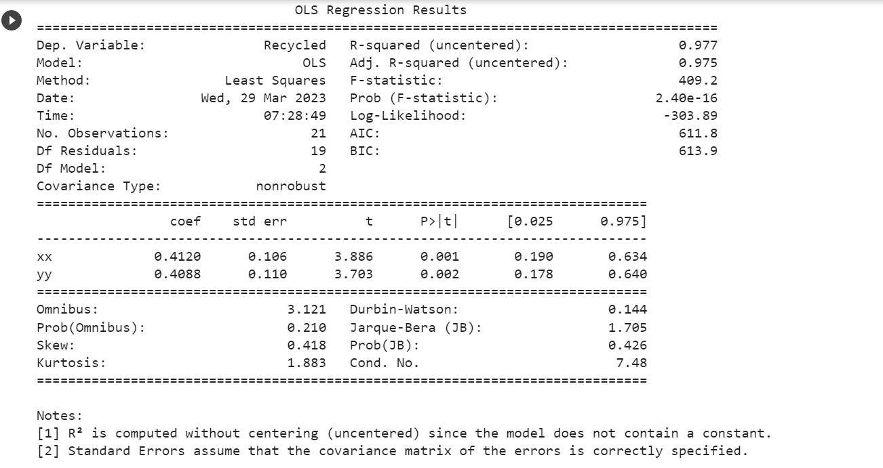

**Future Scope and Feasibility**

If plastic bottle pollution is significantly reduced, the future scope and feasibility of using reverse vending machines will continue to be relevant in promoting sustainable waste management practices. Here are some of the future scopes and feasibility of reverse vending machines if plastic bottle pollution is reduced significantly:

1. Diversification: If plastic bottle pollution is reduced, reverse vending machines could be used to recycle other types of waste, such as aluminum cans, glass bottles, and paper products. This would increase their usefulness and promote more sustainable waste management practices.
2. Increased Efficiency: With reduced plastic bottle pollution, reverse vending machines could become more efficient in handling other types of recyclable materials. This would improve recycling rates and reduce the amount of waste that ends up in landfills or the environment.
3. Innovation: As technology advances, reverse vending machines could be further improved to increase their efficiency and reduce costs. This would make them more attractive to businesses and individuals looking to promote sustainable waste management practices.
4. Accessibility: With reduced plastic bottle pollution, reverse vending machines could be more widely distributed and accessible in public areas such as parks, airports, and train stations. This would make it easier for individuals to recycle and reduce their environmental impact.
5. Partnership: Companies and organizations could partner with reverse vending machine manufacturers and operators to promote responsible recycling behaviour and support sustainable waste management practices. This would increase the visibility and popularity of reverse vending machines, leading to a more sustainable future.

TEAM MEMBERS :

* 1. Dhaval Powel – 70562100156, A047
  2. Siddhaint Patil – 70562100154, A045
  3. Krish Patel – 70562100159, A049
  4. Gaurav Keshari – 70562100138, A036